**Input new website**

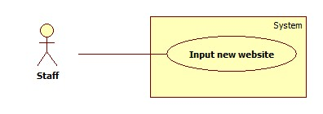

**Use Case Specification**

|  |  |  |  |
| --- | --- | --- | --- |
| **USE CASE - <UC Number>** | | | |
| **Use Case No.** |  | **Use Case Version** | 1.0 |
| **Use Case Name** | Input new website | | |
| **Author** | Nguyen Le Hoang Thien | | |
| **Date** | 21/01/2016 | **Priority** | High |
| **Actor:**   * Staff.   **Summary:**   * This use case allows staff to input new culinary website in order to set parser configuration or parse recipe.   **Goal:**   * Input new cooking website and load its resource to iframe to view.   **Triggers:**   * Staff sends input new website command.   **Preconditions:**   * N/A   **Post Conditions:**   * **Success**: The resource of new website is loaded. * **Fail**: Show error messages.   **Main Success Scenario:**   |  |  |  | | --- | --- | --- | | **Step** | **Actor Action** | **System Response** | | 1 | Staff goes to input new website view. | System require information of new website from staff:   * URL of new website: must be a valid URL format.   [Exception 1] | | 2 | Staff inserts new website URL. |  | | 3 | Staff sends load new website command. | The resources of new website are loaded to view. |   **Exception**   |  |  |  | | --- | --- | --- | | **No** | **Cause** | **System Response** | | 1 | The input URL is invalid. | System shows error message. | | 2 | The new page is cannot connected. | System shows error message. |   **Relationships:** Set parser configuration.  **Business rules:**   * N/A. | | | |

**Set parser configuration**

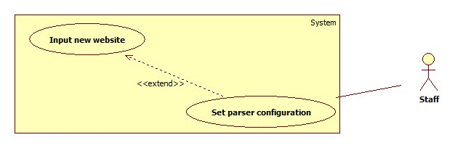

**Use Case Specification**

|  |  |  |  |
| --- | --- | --- | --- |
| **USE CASE - <UC Number>** | | | |
| **Use Case No.** |  | **Use Case Version** | 1.0 |
| **Use Case Name** | Set parser configuration | | |
| **Author** | Nguyen Le Hoang Thien | | |
| **Date** | 21/01/2016 | **Priority** | High |
| **Actor:**   * Staff.   **Summary:**   * Staff can set configuration for inputted website in order to auto parse recipe.   **Goal:**   * Set configuration for each website for auto parse.   **Triggers:**   * Staff sends set configuration command.   **Preconditions:**   * Staff passes input new website use case. * The resource of new website is loaded.   **Post Conditions:**   * **Success**:   + New configuration file is inserted to storage.   * **Fail**:   + Show error message. Storage is unchanged. Log file is generated.  **Main Success Scenario:**   |  |  |  | | --- | --- | --- | | **Step** | **Actor Action** | **System Response** | | 1 | Staff goes to set parser configuration view. | System loads all resource of inputted website to view screen. | | 2 | Staff clicks on each element 3 times for ingredients and steps. | System gets XPath of every element-click.  System inserts XPath into temporary storage. | | 3 | Staff finishes clicking and send “Complete” command. | System loads all XPaths.  System compares all of XPaths to get common XPath for each element. | | 4 | Staff sends add new configuration command.  [Alternative 1]  [Alternative 2] | New parser configuration file is added to system. |   **Alternative Scenario**   |  |  |  | | --- | --- | --- | | **No** | **Actor Action** | **System Response** | | 1 | Staff sends preview command. | System shows all common XPaths for each element and sample data from these XPaths. | | 2 | Staff sends reset command. | All gotten data are cleared. |   **Exception**   |  |  |  | | --- | --- | --- | | **No** | **Cause** | **System Response** | | 1 | System cannot get common XPath. | System will show error message. | | 2 | Staff doesn’t click enough 3 times for each element. | System will show error message.  *Leader comments: quá trình lấy Xpath là wizard, với những element yêu cầu click 3 lần, nếu staff không click đủ 3 lần thì không thể bấm Next để đi tiếp sang bước chọn element khác. |   **Relationships:** Input new website.  **Business rules:**   * After input new website. Staff must be click 3 times for every needed element. 3 times is the greatest of times to system can get XPath exactly.   *Leader comments: Chỉ cần click 3 lần cho ingredient và step, vì hai thứ này có số lượng phần tử không cố định, những thứ khác như Title, Introduction hay Recipe image chỉ có một. Câu cuối hơi cảm tính | | | |

**View logs**

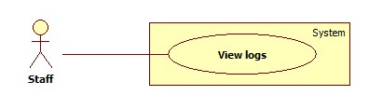

**Use Case Specification**

|  |  |  |  |
| --- | --- | --- | --- |
| **USE CASE - <UC Number>** | | | |
| **Use Case No.** |  | **Use Case Version** |  |
| **Use Case Name** | View logs | | |
| **Author** | Nguyen Le Hoang Thien | | |
| **Date** | 21/01/2016 | **Priority** | Normal |
| **Actor:**   * Staff   **Summary:**   * This use case allows staff view logs from systems.   **Goal:**   * Staff can view logs created by system.   **Triggers:**   * Staff sends view logs command.   **Preconditions:** N/A  **Post Conditions:**   * Success:   + New recipe is created. The new recipe is displayed in Manage Recipe Screen and data is saved in database.  *Leader comment: mục đích của view logs là xem log thôi, sau khi xem logs, staff sẽ biết được cần làm gì (ví dụ food được tìm nhiều nhưng không có món nào match --> tìm thêm công thức có food đó bổ sung vào database…). Phần Success này dành cho Parse manually phù hợp hơn.  - Ngoài ra, staff sẽ có thêm chức năng approve food mà user nhập vào hoặc ingredient trong recipe được scheduler parse. Phần này sẽ họp team để làm rõ lại.   * Fail:   + Database is unchanged. No new recipe is created.  **Main Success Scenario:**   |  |  |  | | --- | --- | --- | | **Step** | **Actor Action** | **System Response** | | 1 | Staff goes to View logs view. | System opens view logs page.  System loads all logs with state “unread” to the page. | | 2 | Staff completes reading all logs and send complete command. | System changes all states of logs to “read”. |   *Lead comments: theo tui, trang view logs nên có 1 số lựa chọn, gồm  - Xem những log chưa được xem (unread)  - Xem những log trong khoảng thời gian xác định (1 tuần/1 tháng trước…)  **Exception**   |  |  |  | | --- | --- | --- | | **No** | **Cause** | **System Response** | | 1 | System cannot connect to log file. | System will show error message. |   **Business rules**   * When staff login to system. Staff can read all logs created by system. By that, staff can know what is happening and know what they should do. | | | |

**Parse manually**

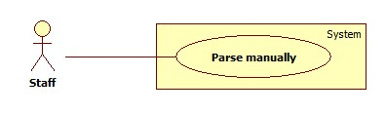

**Use Case Specification**

|  |  |  |  |
| --- | --- | --- | --- |
| **USE CASE - <UC Number>** | | | |
| **Use Case No.** |  | **Use Case Version** | 1.0 |
| **Use Case Name** | Parse manually | | |
| **Author** | Nguyen Le Hoang Thien | | |
| **Date** | 21/01/2016 | **Priority** | High |
| **Actor:**   * Staff.   **Summary:**   * This use case helps staff parse a new recipe manually.   **Goal:**   * Input a new dish’s URL and parse its recipe to system’s storage.   **Triggers:**   * Staff sends parse manually command.   **Preconditions:**   * N/A   **Post Conditions:**   * **Success**: The new recipe is inserted into database. * **Fail**: Show error messages.   **Main Success Scenario:**   |  |  |  | | --- | --- | --- | | **Step** | **Actor Action** | **System Response** | | 1 | Staff goes parse manually view. | System require information of new website from staff:   * URL of new website: must be a valid URL format.   [Exception 1] | | 2 | Staff inserts new dish URL. |  | | 3 | Staff sends load new dish’s website command. | The resources of new website are loaded to view. | | 4 | Staff clicks on element for dish’s name, ingredients and steps. (có thể thêm phần introduction của món ăn, hình đại diện…) | System gets XPath of every element-click.  System inserts XPath into temporary storage. | | 5 | Staff finishes clicking and send “completed” command. | System loads all XPaths.  System gets dish’s name, ingredients and steps through XPaths. | | 6 | Staff sends add new recipe command.  [Alternative 1]  [Alternative 2] | New recipe is added to system. |   **Alternative Scenario**   |  |  |  | | --- | --- | --- | | **No** | **Actor Action** | **System Response** | | 1 | Staff sends preview command. | System shows all data gotten include dish’s name, ingredients and steps. | | 2 | Staff edits some gotten data. | System edits gotten data in temporary storage. | | 3 | Staff sends reset command. | All gotten data are cleared. |   **Exception**   |  |  |  | | --- | --- | --- | | **No** | **Cause** | **System Response** | | 1 | The input URL is invalid. | System will show error message. | | 2 | The culinary page is cannot connected. | System will show error message. | | 3 | The staff clicks missing some elements. | System will show error message. |   **Relationships:** N/A  **Business rules:**   * When staff finds a new dish and want to parse it to system’s storage. Instead parsing automatically, he/ she can parse manually through a several clicks. This use case can use when a recipe have a strange XPaths too. | | | |